Current IU Position Paper on generative AI:
Authors‘ Rights Status quo & Recommendations for Action

Berlin, 19.09.2023. The Initiative Urheberrecht (IU) has, through extensive exchange with leading AI-scientists, gained a deep insight into the functionality of generative AI and from this has developed a policy position paper – complete with suggestions for the hotly discussed AI Act.

Around 140,000 authors and performers, from sectors such as journalism, photography, music, theatre, fiction/non-fiction, TV + film, illustration, visual arts, design, etc., are represented through the associations and unions which together form the German umbrella organisation IU. Across Europe there are several million authors and performers who’s works, performances, and recordings are the starting point for material and ideal value creation, forming an indispensable pilar of the European value und economic community.

Since around 2010, their copyright protected works and services protected through related property rights, as far as digitally accessible, have been used to build comprehensive databanks for the training of Artificial Intelligence-Systems.

Matthias Hornschuh, composer and spokesperson for the IU, explains: “Whether the fear of AI is justified can be discussed at length; AI is here, and we will find a way to deal with it. However, AI certainly justifies anger. The existing models depend predominantly on unlawfully acquired works and data; the regulations, which were first established years after the beginning of scraping and presumably do not apply to the training of generative AI, will not solve this problem. Even if only for the sake of legal certainty, bold regulations are unavoidable. In order to support this, we have collaborated extensively with experts on copyright and AI research and, on the basis of the current status quo, have developed recommendations for action: for the AI Act and beyond.”

In the exchange between AI-researchers from various different universities and the Fraunhofer Institut, as well as specialist lawyers from guilds, trade unions und collecting societies, the IU is working on an ongoing evaluation of the copyright status quo of current generative AI-Systems. The position paper will provide an insight into the formation of these opinions, in conjunction with suggestions for the AI Act.

Please find attached both papers in English.
The translations will be published on www.urheber.info soon.

German Version:
Positionspapier zu generativer Künstlicher Intelligenz | Initiative Urheberrecht

Further enquiries:
Katharina Uppenbrink | Managing Director
Initiative Urheberrecht (Authors‘ Rights Initiative)
katharina.uppenbrink@urheber.info | www.urheber.info
Markgrafendamm 24, Haus 18 | D-10245 Berlin
Tel.: +49 30 2091 5807 | +49 160 9095 4016

DE Initiative Urheberrecht
EN About us | Initiative Urheberrecht

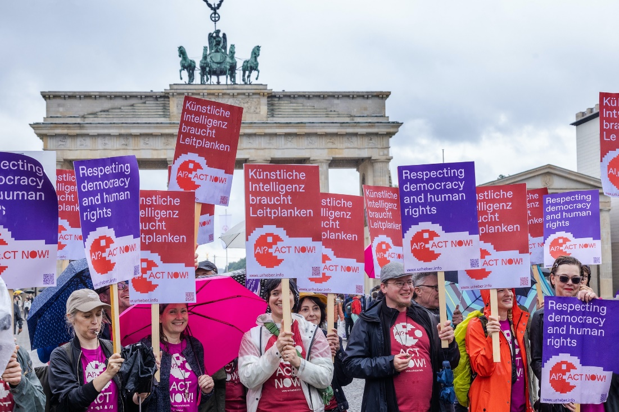

Die Initiative Urheberrecht vertritt die Interessen von rund 140.000 Urheber:innen und ausübenden Künstler:innen in den Bereichen Belletristik und Sachbuch, Bildende Kunst, Design, Dokumentarfilm, Film und Fernsehen, Fotografie, Illustration, Journalismus, Komposition, Orchester, Schauspiel, Spieleentwicklung, Tanz und vielen mehr.

Initiative Urheberrecht (Authors’ Rights Initiative)
The initiative represents the interests of some 140,000 authors and performers in the fields of acting, composition, dance, design, documentary film, fiction and non-fiction, film and television, game development, illustration, journalism, orchestra, photography, visual arts, and many more.

